**USER MANUAL**

**Designing an Animal Adoption Web Application for Society for the Prevention of Cruelty to Animals (SPCA Sandakan)**

**PREPARED BY**

**SHERLY EDRIANA PHILIP**

**ADMIN SITE**

1. **HOME PAGE**

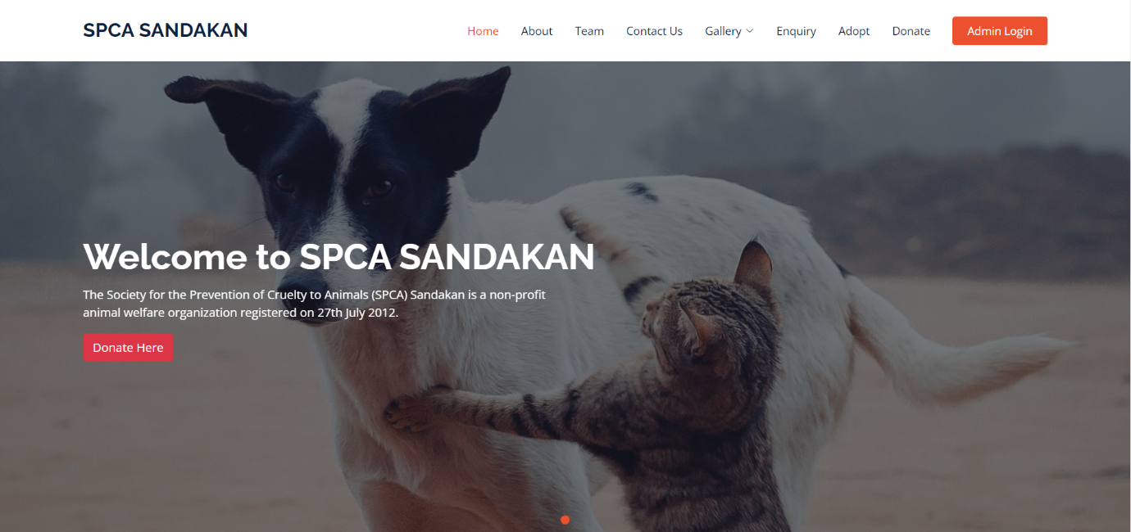

The figure above shows the home page when the link is accessed. The admin and public can navigate to any pages of this page.

1. Login Page

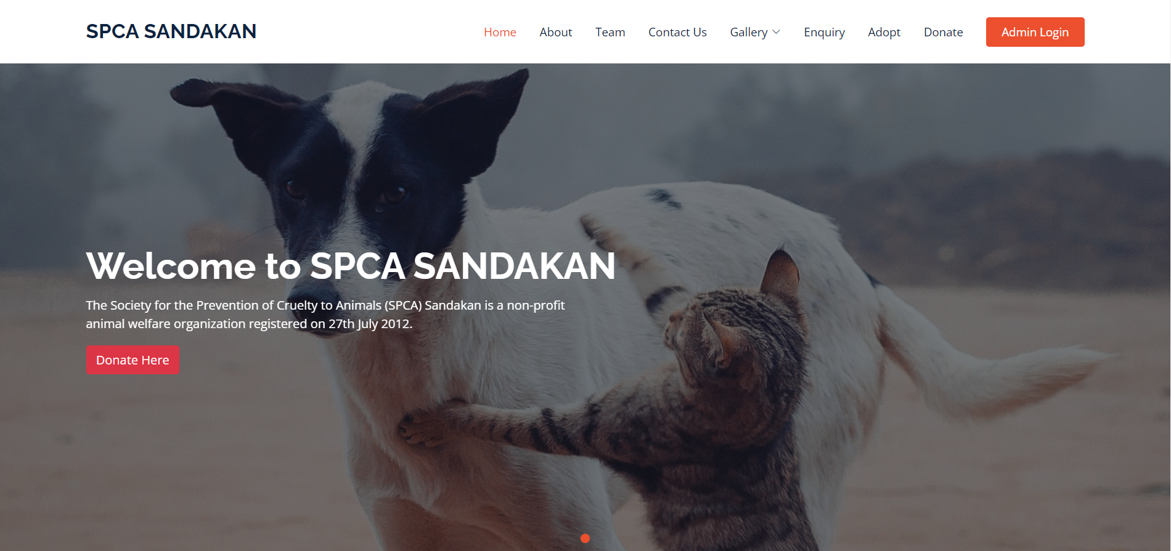

Login Button

The figure shows the login button that admin should click in order to access the web application.

1. Login

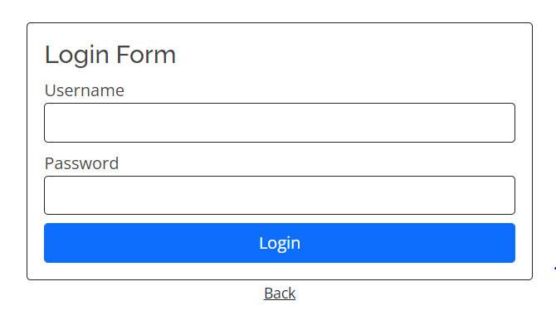

1. Login button
2. Password
3. Username

The figure is a login form of the web application. The admin will be given username and email for them to enter the web application.

Username: admin

Password: 1234

3. List of Adoption

1. Dashboard site

2. List of Animals

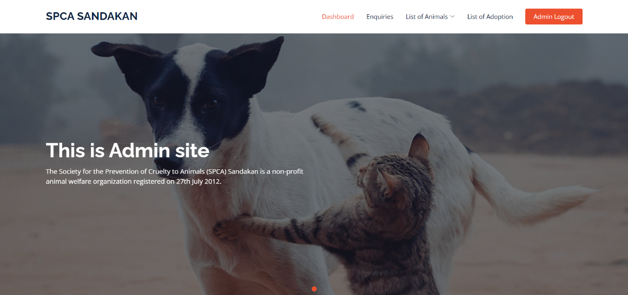

3. Admin Logout

1. Enquiry

Figure 4 shows the dashboard page that will be only accessible to the SPCA Sandakan admin.

1. Admin click the enquiry to access the list of enquiry page.
2. Admin click List of Animal to access Cats and Dogs management.
3. Admin click Adoption to access the list of adoptions.
4. Admin click on the Logout button to log out of the web application.

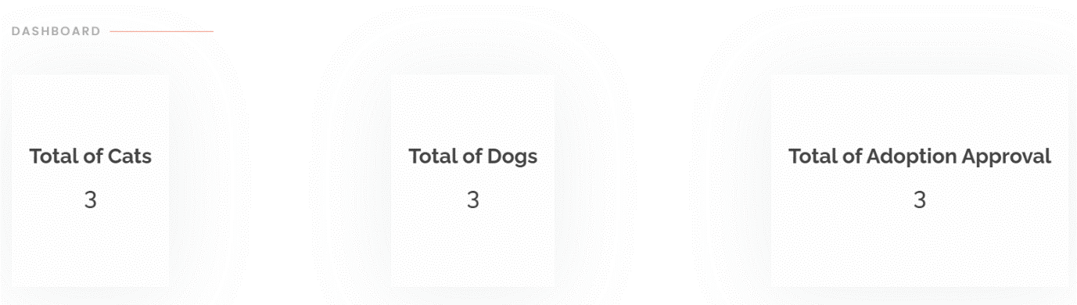

The figure shows the dashboard site where the total of cats, dogs and adoption approval are displayed.

1. List of enquiries

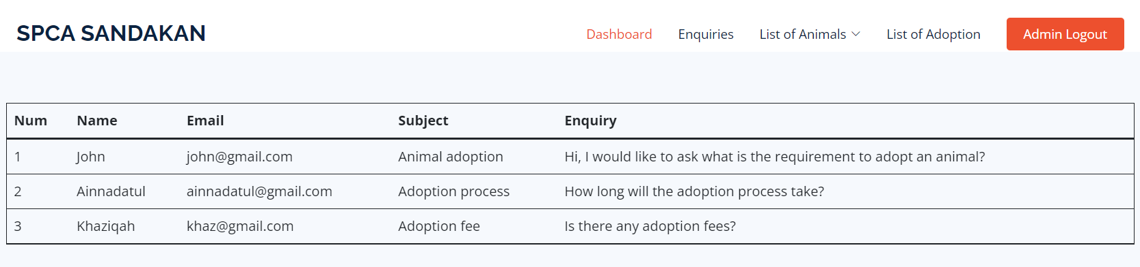

The figure shows where the public sent the enquiries to the web application and the enquiries are displayed here.

1. List of cats

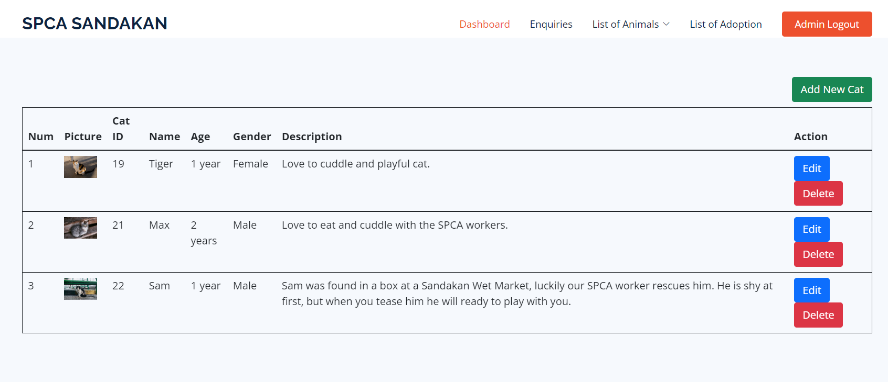

1. Delete cat info
2. Edit cat info
3. Add new cat

Figure display the list of cats. This is where the admin manages the cat information such as add new cat, edit cat info and delete cat info.

1. Add cat info
2. Upload picture

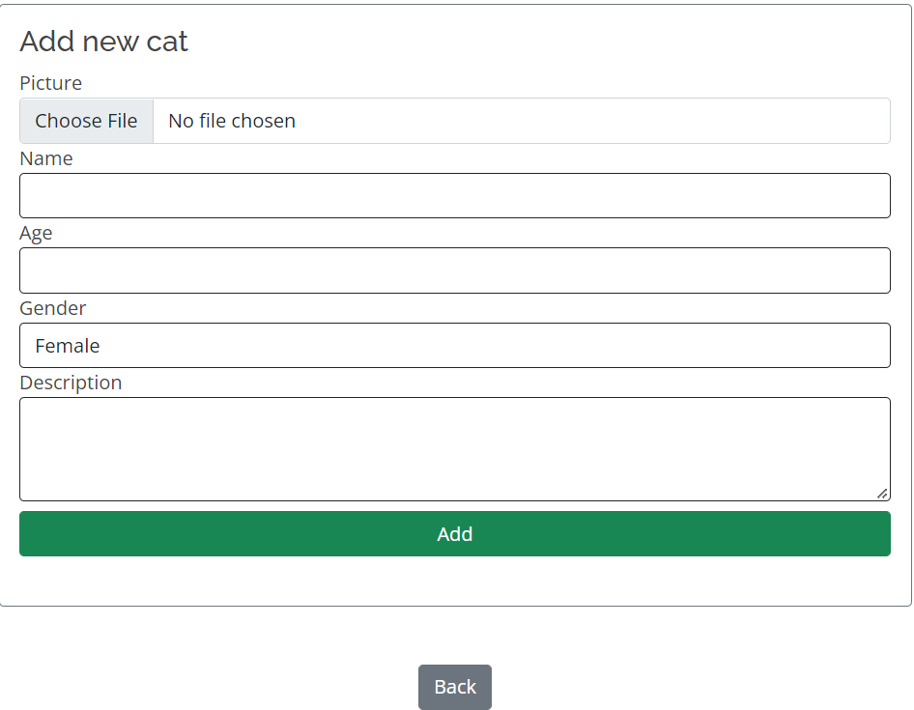

7. Click back if wish to cancel add new cat

6. Click Add button

5. Describe the cat

4. Select gender

3. Type Age

2. Type Name

1. Edit cat information
2. Upload cat picture

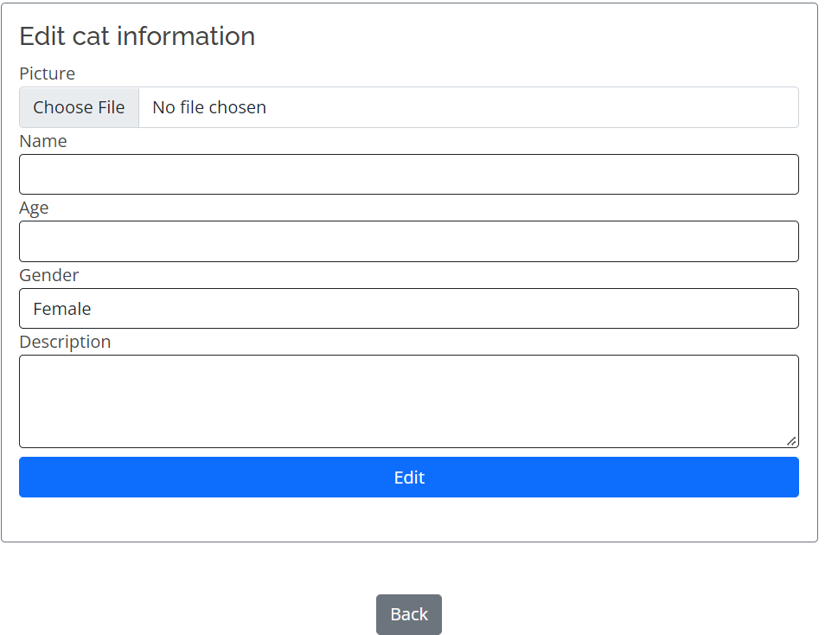

1. Click Back button if wish to cancel the edit
2. Click Edit button
3. Describe the cat
4. Select gender
5. Type age
6. Type name
7. List of dogs table

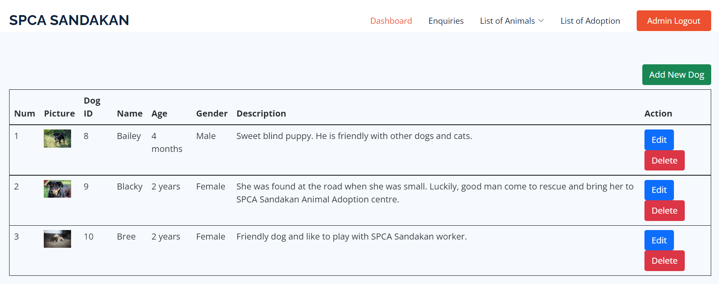

1. Edit dog info
2. Edit dog info
3. Add new dog
4. Add new dog

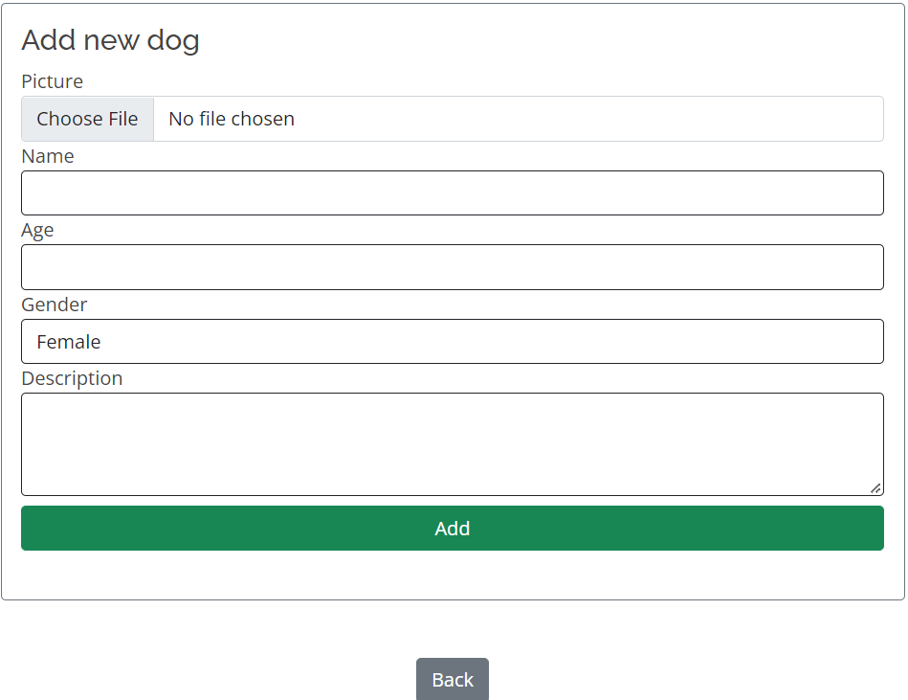

1. Click Back button if want to cancel add
2. Click add button
3. Describe the dog
4. Select gender
5. Type age
6. Type name
7. Upload dog picture
8. Edit Dog Info

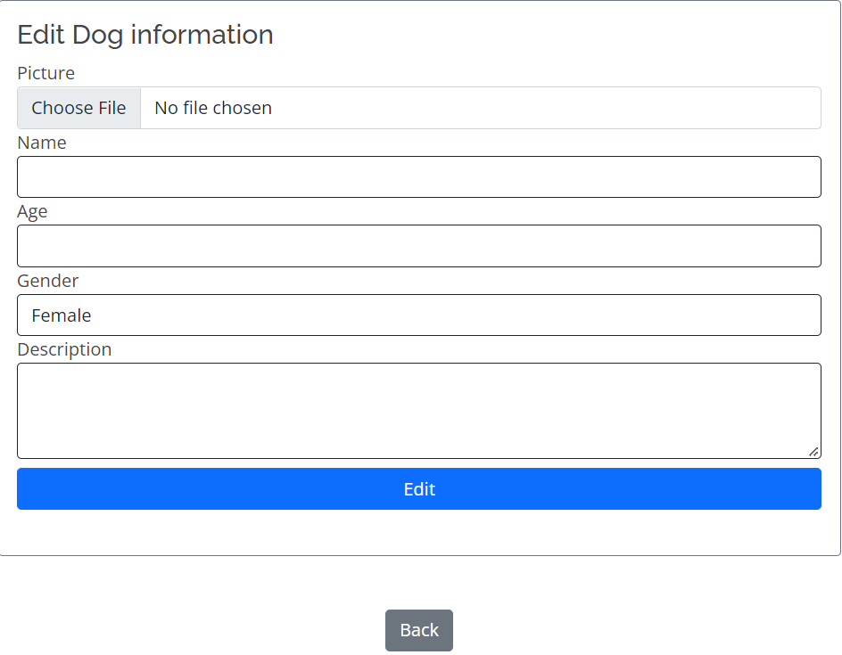

1. Click back button if don’t want to edit dog info
2. Click edit button
3. Describe the dog
4. Select gender
5. Type age
6. Type dog name
7. Upload dog picture
8. List of adoptions
9. Select end adoption date

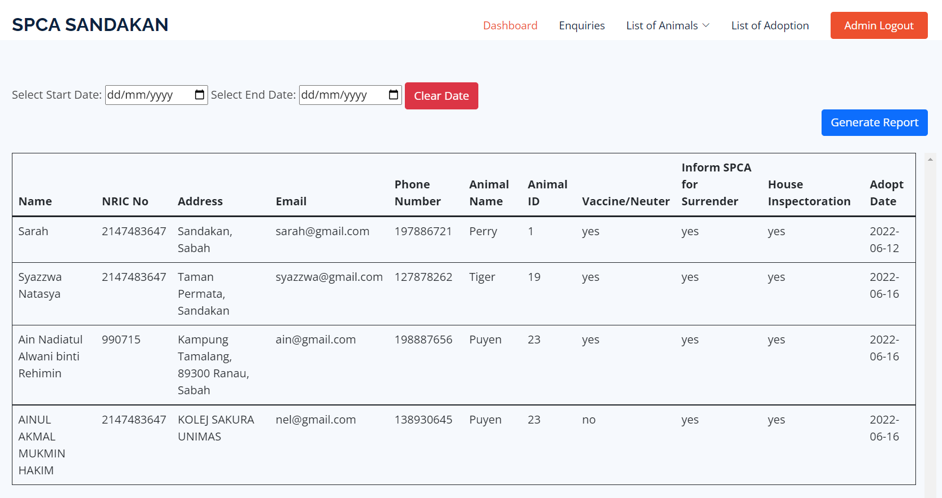

1. Clear date button
2. Clear date button
3. Select start adoption date

The figure above shows the list of adoption. This is where the public apply for adoption and the list will displayed here. The SPCA Sandakan admin only can view the list of adoption.

1. Logout button
2. Generate report

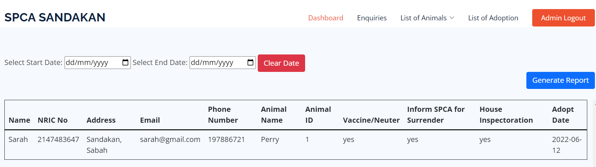

The figure above shows the result after generate the report based on selected adoption date. The SPCA Sandakan admin can click the “Admin Logout” button to log out from the web application.

**PUBLIC SITE**

1. **Homepage**

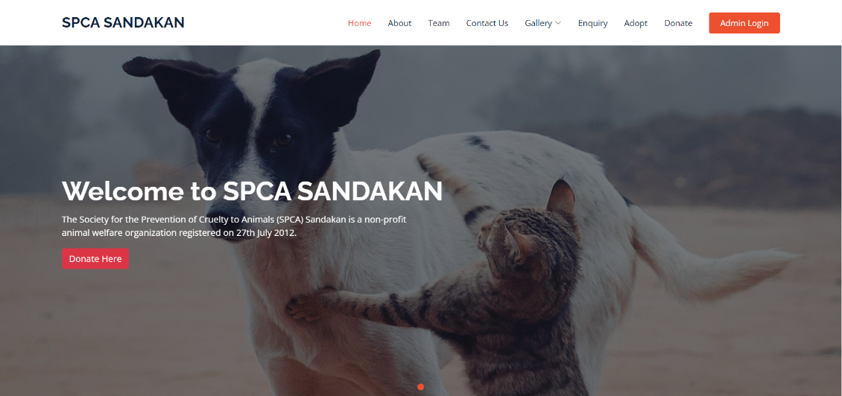

The figure above shows the home page when the link is accessed. The public can navigate to any section of this page except the “Admin Login” button.

1. **About Page**

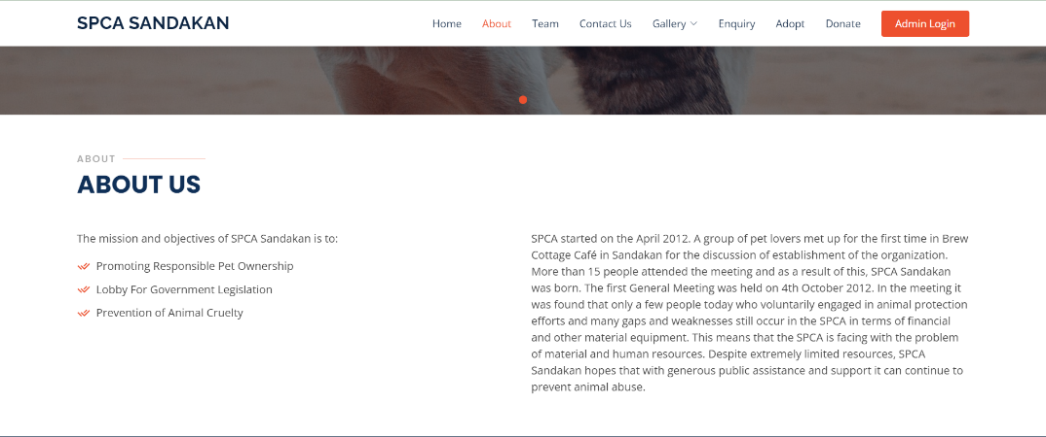

About us button

The figure shows when the public click “About” button it will automatically scroll to About section.

1. **Team Page**

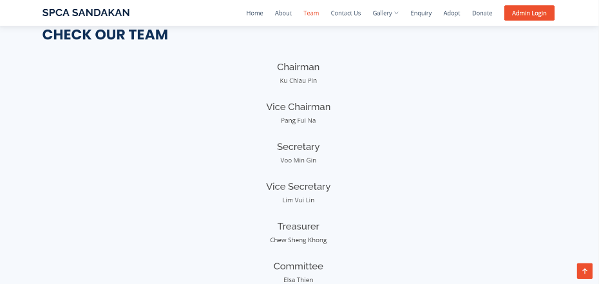

Team button

The figure shows when the public click Team button, it will automatically scroll to Team section.

1. **Contact Us**

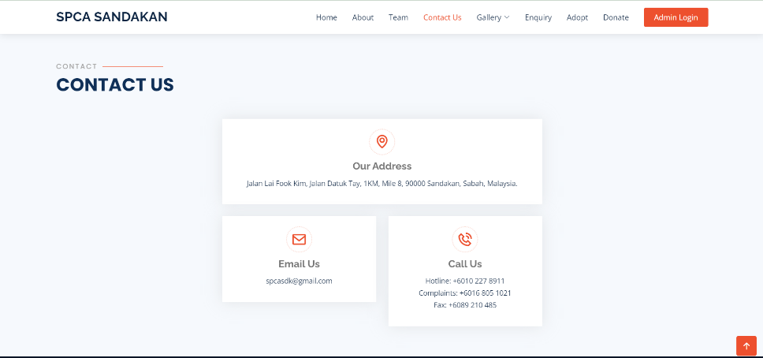

Contact Us button

The figure shows when the public click Team button, it will automatically scroll to Contact Us section.

1. **Cat Gallery**

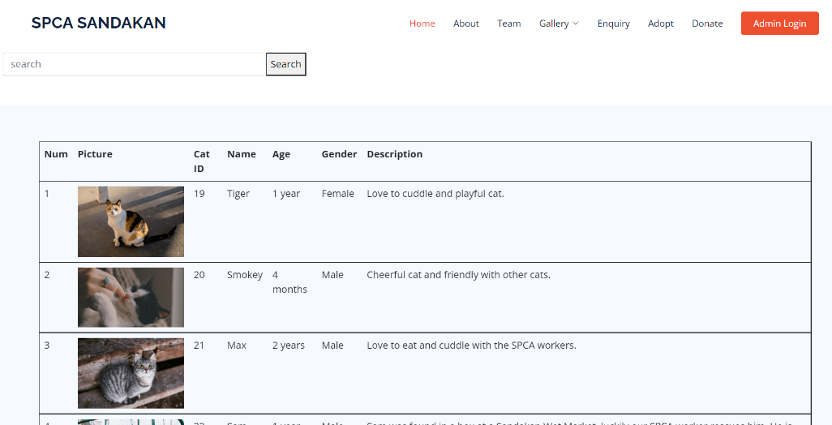

Search button

Search bar

The figure above is cat gallery. This is where the public want to view the animal that available to adopt. The public also can search the cat by name or ID.

1. **Dog Gallery**

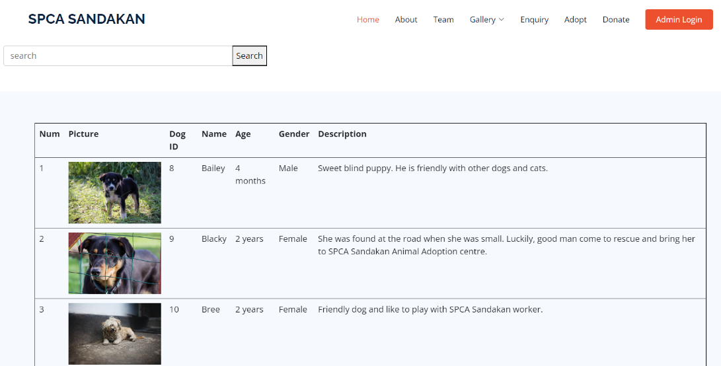

Search button

Search bar

The figure above is dog gallery. This is where the public want to view the animal that available to adopt. The public also can search the cat by name or ID.

1. **Adopt Form Page**

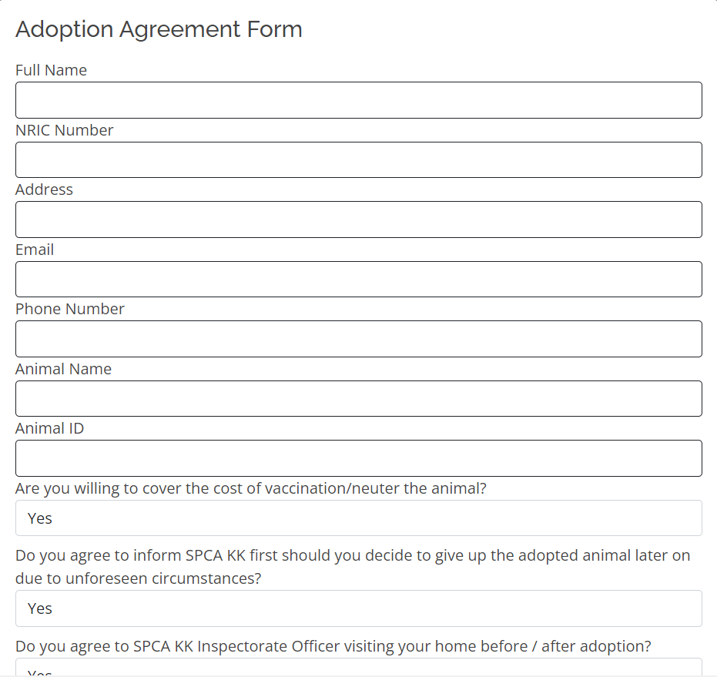

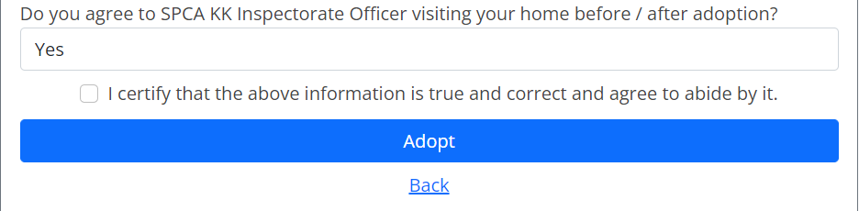

The figure above shows adoption form. In order to fill the adoption form, the public user have to go to animal gallery to know what is the animal name and the animal ID, then they can fill in the form because the form requires Animal Name and Animal ID.

1. **Enquiry Page**

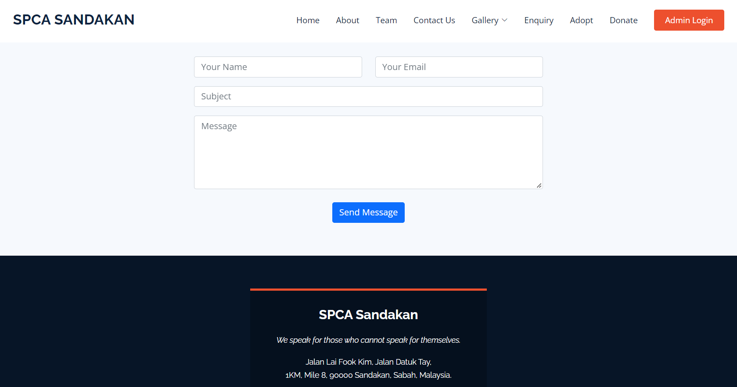

Enquiry button

The figure shows the enquiry page. This is where the public can send an enquiry regarding the SPCA Sandakan services.

1. **Donate Page**

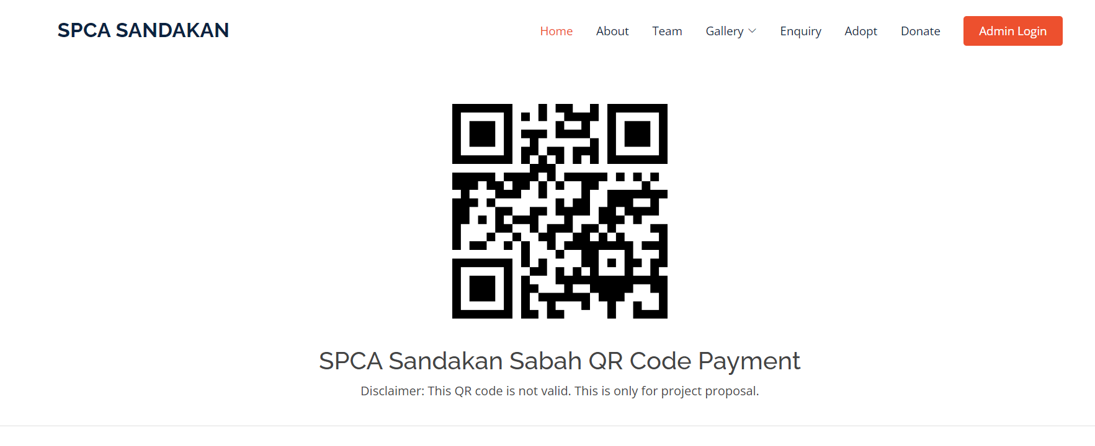

The figure above shows the QR code for donation. The public can donate by scan the QR code.